OCCUPATIONAL HEALTH & SAFETY POLICY

Top management at Advance Excavations are committed to providing safe and healthy working conditions for the prevention of work-related injuries and ill health, for all employees, contractors and other relevant interested parties involved with our business. We are committed to eliminate workplace hazards and reduce OH&S risks, through the implementation and continual improvement of the company’s Occupational Health and Safety Management System.

Occupational Health & Safety Objectives

The Top management and staff at Advance Excavations are committed and will strive to:

- Prevent and eliminate work related injuries and illnesses
- Identify, assess and control workplace hazards and risks to provide a healthy and safe workplace
- Develop procedures, processes and instructions to ensure safe systems of work are implemented and maintained

As part of the company’s systems and processes top management are committed to:

- Ensure consultation and participation of workers, and where they exist worker’s representatives, in regard to this policy, processes, procedures and activities related to the company’s Occupational Health and Safety Management System
- Ensure that this policy is retained as documented information, and available to interested parties
- Define and meet objectives, by documenting and monitoring measurable occupational health and safety objectives and targets to ensure the prevention of work-related injuries and ill health
- Conduct regular management review meetings to ensure the company’s Occupational Health and Safety management system is reviewed and controlled appropriately
- Report, investigate and apply corrective actions to all workplace incidents
- Fulfil all legal and other requirements applicable to the company
- Continually monitor and improve our health and safety performance and the effectiveness of our Occupational Health and Safety Management System
- Conduct OH&S audits of key processes within the business as part of our Continual Improvement Process
- Ensure our Occupational Health and Safety Management System is conformant and certified to ISO 45001:2018 Occupational health and safety management systems
- Review this policy annually

Approved by Daniel Garcia
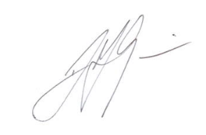
Operations Manager
22nd August 2025

