QUALITY POLICY

Advance Excavations is a specialist provider of HV and LV electrical installations, NBN and communications installations, civil construction and project management. Our management and staff are committed to providing high quality products and services that meet and exceed our customers’ expectations.

Quality Objectives

The Management and Staff at Advance Excavations are committed and will strive to:

- Provide an exceptionally high-quality level of products and services to our customers
- Manage our processes to maximise efficiency and productivity
- Follow up on services and products provided, to ascertain that our goals and objectives are being achieved

As part of our systems and processes we will:

- Train, educate and communicate with employee’s, contractors and other relevant interested parties in regard to this policy and quality expectations where necessary
- Ensure that this policy is available to interested parties
- Define and meet objectives, by documenting and monitoring measurable quality targets
- Comply to statutory, regulatory and other requirements
- Apply a Plan, Do, Check, Act methodology to our Quality Management System
- Continually monitor and improve our quality performance and the effectiveness of our Quality Management System
- Apply Risk Based Thinking within our systems, operations and processes
- Conduct audits of key processes within the business as part of our Continual Improvement Process
- Ensure our Quality Management System is conformant and certified to ISO 9001:2015
- Review this policy annually

Approved by Daniel Garcia
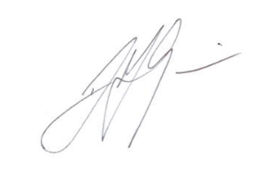
Operations Manager
28th July 2023

