ENVIRONMENTAL POLICY

Advance Excavations management are committed to minimising, where reasonably practicable, our impact on the environment for the benefit of current and future generations. We will strive to the continual improve our environmental management system, prevention of pollution and minimisation of waste relevant to our business processes.

Environmental Objectives

The Management and Staff at Advance Excavations are committed and will strive to:

- Implement processes to minimise waste and protect the environment
- Actively promote recycling both on our work sites and within our administrational processes

As part of our systems and processes we will:

- Train, educate and communicate with employee’s, contractors and other relevant interested parties in regard to this policy and expectations towards protecting the environment where necessary
- Ensure that this policy is available to interested parties
- Define and meet objectives, by documenting and monitoring measurable environmental targets consistent with this policy
- Conduct regular management review meetings to ensure our Environmental Management System is reviewed and controlled appropriately
- Report, investigate and apply corrective actions to all environmental incidents and non-compliances
- Comply to environmental statutory, regulatory and other requirements
- Document and mitigate all company environmental aspects and impacts where reasonably practicable
- Conduct audits of key processes within the business as part of our Continual Improvement Process
- Ensure our Environmental Management System is conformant and certified to ISO 14001:2015
- Review this policy annually

Approved by Daniel Garcia
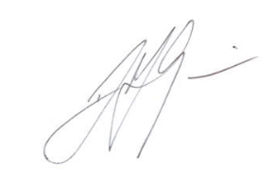
Operations Manager
28th July 2023

